Session 16 – Assignment

1. Use the below given data set
Data Set
2. Perform the below given activities:
a. Predict the no of comments in next H hrs
Note:-
1. Use LASSO, Elastic Net and Ridge and other regression techniques that are covered in the module
2. Report the training accuracy and test accuracy
3. compare with linear models and report the accuracy
4. create a graph displaying the accuracy of all models

Attribute Information:

(39 - This describes the H hrs, for which we have the target variable/ comments received.

, 54 -Target Variable - Decimal Target The no of comments in next H hrs(H is given in Feature no 39).

39
H Local
ï¿¼Decimal(0-23) Encoding Other feature
This describes the H hrs, for which we have the target variable/ comments received.

54
Target Variable
Decimal
Target
The no of comments in next H hrs(H is given in Feature no 39).

Prediction Accuracy

A good learner is the one which has good prediction accuracy; in other words, which has the smallest prediction error.
Let us try to understand the prediction problem intuitively. Consider the simple case of fitting a linear regression model to the observed data. A model is a good fit, if it provides a high R2 value.
1. Use LASSO, Elastic Net and Ridge and other regression techniques that are covered in the module

library(tidyverse) library(caret) library(glmnet)
# Load the data setwd("~/Dataset/Dataset/Training")

Features_Variant_1 <- read.csv("C:/users/seshan/Documents/Dataset/Dataset/Training/Features_Variant_1.csv")

View(Features_Variant_1)

Features.data <- na.omit(Features_Variant_1)

# Split the data into training and test set set.seed(123)
training.samples <- Features$X0.19 %>%

createDataPartition(p = 0.8, list = FALSE)

train.data <- Features_Variant_1[training.samples, ]

test.data <- Features_Variant_1[-training.samples, ]

# Predictor variables

x <- model.matrix(X0.19~., train.data)[,-1]

# Outcome variable

y <- train.data$X0.19

glmnet(x, y, alpha = 1, lambda = NULL)

# Find the best lambda using cross-validation set.seed(123)
cv <- cv.glmnet(x, y, alpha = 0)

# Display the best lambda value
cv$lambda.min plot(cv$lambda.min)
# Fit the final model on the training data

model <- glmnet(x, y, alpha = 0, lambda = cv$lambda.min)

plot(model)

# Display regression coefficients coef(model)

# Make predictions on the test data

x.test <- model.matrix(X0.19 ~., test.data)[,-1]

predictions <- model %>% predict(x.test) %>% as.vector()

# Model performance metrics data.frame(
RMSE = RMSE(predictions, test.data$X0.19), Rsquare = R2(predictions, test.data$X0.19)
)

#Computing lasso regression

# Find the best lambda using cross-validation set.seed(123)
cv <- cv.glmnet(x, y, alpha = 1)

# Display the best lambda value cv$lambda.min
# Fit the final model on the training data

model <- glmnet(x, y, alpha = 1, lambda = cv$lambda.min)
# Dsiplay regression coefficients coef(model)
# Make predictions on the test data

x.test <- model.matrix(X0.19 ~., test.data)[,-1]

predictions <- model %>% predict(x.test) %>% as.vector()

# Model performance metrics data.frame(
RMSE = RMSE(predictions, test.data$X0.19), Rsquare = R2(predictions, test.data$X0.19))
#Computing elastic net regession

# Build the model using the training set set.seed(123)
model <- train(X0.19 ~., data = train.data, method = "glmnet", trControl = trainControl("cv", number = 10),
tuneLength = 10

)

# Best tuning parameter model$bestTun plot(model$bestTun)
# Coefficient of the final model. You need

# to specify the best lambda coef(model$finalModel, model$bestTune$lambda)
# Make predictions on the test data

x.test <- model.matrix(X0.19 ~., test.data)[,-1]

predictions <- model %>% predict(x.test)
# Model performance metrics data.frame(
RMSE = RMSE(predictions, test.data$X0.19),

Rsquare = R2(predictions, test.data$X0.19)

)

#Comparing the different models

#Using caret package

#Setup a grid range of lambda values:

lambda <- 10^seq(-3, 3, length = 100)

#Compute ridge regression

# Build the model set.seed(123) ridge <- train(
X0.19 ~., data = train.data, method = "glmnet", trControl = trainControl("cv", number = 10), tuneGrid = expand.grid(alpha = 0, lambda = lambda)
)

# Model coefficients

coef(ridge$finalModel, ridge$bestTune$lambda)

# Make predictions

predictions <- ridge %>% predict(test.data)

plot(predictions)

# Model prediction performance data.frame(
RMSE = RMSE(predictions, test.data$X0.19),
Rsquare = R2(predictions, test.data$X0.19)

)

#Compute lasso regression

# Build the model set.seed(123) lasso <- train(
X0.19 ~., data = train.data, method = "glmnet", trControl = trainControl("cv", number = 10), tuneGrid = expand.grid(alpha = 1, lambda = lambda)
)

plot( lasso)

# Model coefficients

coef(lasso$finalModel, lasso$bestTune$lambda)

# Make predictions

predictions <- lasso %>% predict(test.data)

# Model prediction performance data.frame(
RMSE = RMSE(predictions, test.data$X0.19), Rsquare = R2(predictions, test.data$X0.19)
)

#Elastic net regression

# Build the model set.seed(123) elastic <- train(
X0.19 ~., data = train.data, method = "glmnet", trControl = trainControl("cv", number = 10),
tuneLength = 10

)

# Model coefficients

coef(elastic$finalModel, elastic$bestTune$lambda)

# Make predictions

predictions <- elastic %>% predict(test.data)

plot( predictions)

# Model prediction performance data.frame(
RMSE = RMSE(predictions, test.data$X0.19), Rsquare = R2(predictions, test.data$X0.19)
)

#Comparing models performance:

models <- list(ridge = ridge, lasso = lasso, elastic = elastic)

resamples(models) %>% summary( metric = "RMSE")

#k-fold Cross Validation

# load the library library(caret)

# define training control
train_control <- trainControl(method="cv", number=10)

# fix the parameters of the algorithm

grid <- expand.grid(.fL=c(0), .usekernel=c(FALSE))

# train the model

model <- train(X0.19~., data=Features_Variant_1, trControl=train_control, method="nb", tuneGrid=grid)

# summarize results print(model)

# load the library library(caret)

# define training control

train_control <- trainControl(method="repeatedcv", number=10, repeats=3)

# train the model

model <- train(X0.19~., data=Features_Variant_1, trControl=train_control, method="nb")

# summarize results print(model)

#create a graph displaying the accuracy of all models plot(model)
plot(varImp(ridge$finalModel))

plot(cv)

plot(ridge)

hist(Features$X0.19,col = "green")

hist(Features$X24,col = "red")
hist(Features$X11.291044776119403,col = 'yellow')

fit = glmnet(x, y)

plot(fit)

cvfit = cv.glmnet(x, y)

plot(cvfit)

tfit=glmnet(x,y,lower=-.7,upper=.5)

plot(tfit)

> library(tidyverse)
> library(caret)
> library(glmnet)
> # Load the data
> setwd("~/Dataset/Dataset/Training")
>
> Features_Variant_1 <- read.csv("C:/users/seshan/Documents/Dataset/Dataset/Training/
Features_Variant_1.csv")
> View(Features_Variant_1)
> Features.data <- na.omit(Features_Variant_1)
> # Split the data into training and test set
> set.seed(123)
> training.samples <- Features$X0.19 %>%
+ createDataPartition(p = 0.8, list = FALSE)
> train.data <- Features_Variant_1[training.samples, ]
> test.data <- Features_Variant_1[-training.samples, ]
> # Predictor variables
> x <- model.matrix(X0.19~., train.data)[,-1]
> # Outcome variable
> y <- train.data$X0.19
> glmnet(x, y, alpha = 1, lambda = NULL)

Call: glmnet(x = x, y = y, alpha = 1, lambda = NULL)

 | Df | %Dev | Lambda
[1,] | 0 | 0.00000 | 18.250000
[2,] | 1 | 0.04881 | 16.630000
[3,] | 1 | 0.08933 | 15.150000
[4,] | 1 | 0.12300 | 13.810000
[5,] | 1 | 0.15090 | 12.580000
[6,] | 1 | 0.17410 | 11.460000
[7,] | 1 | 0.19330 | 10.440000
[8,] | 1 | 0.20930 | 9.516000
[9,] | 1 | 0.22260 | 8.671000
[10,] 1 0.23360 7.900000 [11,] 1 0.24270 7.198000

[12,] | 1 | 0.25030 | 6.559000
[13,] | 1 | 0.25660 | 5.976000
[14,] | 2 | 0.26350 | 5.445000
[15,] | 2 | 0.26950 | 4.962000
[16,] | 3 | 0.27660 | 4.521000
[17,] | 3 | 0.28290 | 4.119000
[18,] | 4 | 0.28840 | 3.753000
[19,] | 4 | 0.29290 | 3.420000
[20,] | 4 | 0.29670 | 3.116000
[21,] | 6 | 0.30040 | 2.839000
[22,] | 6 | 0.30370 | 2.587000
[23,] | 6 | 0.30640 | 2.357000
[24,] | 7 | 0.30870 | 2.148000
[25,] | 7 | 0.31060 | 1.957000
[26,] | 8 | 0.31210 | 1.783000
[27,] | 8 | 0.31350 | 1.625000
[28,] | 8 | 0.31490 | 1.480000
[29,] | 8 | 0.31610 | 1.349000
[30,] | 8 | 0.31710 | 1.229000
[31,] | 8 | 0.31790 | 1.120000
[32,] | 8 | 0.31860 | 1.020000
[33,] | 8 | 0.31920 | 0.929700
[34,] | 8 | 0.31970 | 0.847100
[35,] | 9 | 0.32020 | 0.771900
[36,] | 9 | 0.32060 | 0.703300
[37,] | 9 | 0.32090 | 0.640800
[38,] | 9 | 0.32120 | 0.583900
[39,] | 10 | 0.32150 | 0.532000
[40,] | 10 | 0.32180 | 0.484800
[41,] | 11 | 0.32200 | 0.441700
[42,] | 11 | 0.32240 | 0.402500
[43,] | 11 | 0.32270 | 0.366700
[44,] | 12 | 0.32290 | 0.334100
[45,] | 12 | 0.32320 | 0.304400
[46,] | 13 | 0.32330 | 0.277400
[47,] | 14 | 0.32370 | 0.252800
[48,] | 16 | 0.32390 | 0.230300
[49,] | 17 | 0.32420 | 0.209800
[50,] | 17 | 0.32440 | 0.191200
[51,] | 18 | 0.32460 | 0.174200
[52,] | 22 | 0.32480 | 0.158700
[53,] | 22 | 0.32500 | 0.144600
[54,] | 23 | 0.32520 | 0.131800
[55,] | 24 | 0.32540 | 0.120100
[56,] | 24 | 0.32550 | 0.109400
[57,] | 26 | 0.32570 | 0.099690
[58,] | 29 | 0.32590 | 0.090830
[59,] | 29 | 0.32600 | 0.082770
[60,] | 30 | 0.32620 | 0.075410
[61,] | 30 | 0.32630 | 0.068710
[62,] | 30 | 0.32640 | 0.062610
[63,] | 31 | 0.32640 | 0.057050
[64,] | 31 | 0.32650 | 0.051980
[65,] | 34 | 0.32660 | 0.047360
[66,] | 35 | 0.32660 | 0.043150
[67,] | 36 | 0.32680 | 0.039320
[68,] | 36 | 0.32700 | 0.035830
[69,] | 37 | 0.32730 | 0.032640
[70,] | 38 | 0.32750 | 0.029740
[71,] | 37 | 0.32770 | 0.027100
[72,] | 40 | 0.32790 | 0.024690
[73,] | 40 | 0.32820 | 0.022500
[74,] | 45 | 0.32840 | 0.020500
[75,] | 45 | 0.32880 | 0.018680

[76,] | 46 | 0.32930 | 0.017020
[77,] | 46 | 0.32960 | 0.015510
[78,] | 47 | 0.32980 | 0.014130
[79,] | 47 | 0.33000 | 0.012880
[80,] | 47 | 0.33010 | 0.011730
[81,] | 47 | 0.33030 | 0.010690
[82,] | 47 | 0.33040 | 0.009740
[83,] | 47 | 0.33050 | 0.008875
[84,] | 47 | 0.33060 | 0.008086
[85,] | 48 | 0.33070 | 0.007368
[86,] | 48 | 0.33080 | 0.006713
[87,] | 48 | 0.33090 | 0.006117
[88,] | 48 | 0.33090 | 0.005574
[89,] | 48 | 0.33100 | 0.005078
[90,] | 48 | 0.33100 | 0.004627
[91,] | 48 | 0.33110 | 0.004216
[92,] | 48 | 0.33110 | 0.003842
[93,] | 49 | 0.33120 | 0.003500
[94,] | 49 | 0.33120 | 0.003189
[95,] | 49 | 0.33120 | 0.002906
[96,] | 49 | 0.33120 | 0.002648
[97,] | 49 | 0.33130 | 0.002413
[98,] | 49 | 0.33130 | 0.002198
[99,] | 49 | 0.33130 | 0.002003
[100,] | 49 | 0.33130 | 0.001825
> # Find the best lambda using cross-validation
> set.seed(123)
> cv <- cv.glmnet(x, y, alpha = 0)
> # Display the best lambda value
> cv$lambda.min
[1] 3.189382
> plot(cv$lambda.min)
> # Fit the final model on the training data
> model <- glmnet(x, y, alpha = 0, lambda = cv$lambda.min)
> plot(model)
> # Display regression coefficients
> coef(model)
54 x 1 sparse Matrix of class "dgCMatrix"
s0 (Intercept) -2.538449e+00
X634995 4.086976e-08
X0 -2.391902e-05
X463 -1.118531e-05
X1 7.735292e-04
X0.0 1.350121e-02
X806.0 1.553809e-03
X11.291044776119403 9.304117e-03
X1.0 1.793778e-04
X70.49513846124168 2.001045e-02
X0.0.1 -1.965736e-02
X806.0.1 -1.021345e-03
X7.574626865671642 2.932718e-02
X0.0.2 1.122924e-01
X69.435826365571 -3.244738e-03
X0.0.3 -7.678915e-03
X76.0 -2.361222e-04
X2.6044776119402986 2.333540e-02
X0.0.4 1.156420e-01
X8.50550186882253 4.524854e-03
X0.0.5 -1.178544e-02
X806.0.2 -1.639273e-03
X10.649253731343284 -3.665694e-03
X1.0.1 -1.572424e-02
X70.25478763764251 5.195732e-03
X.69.0 1.960444e-04
X806.0.3 -5.160122e-04
X4.970149253731344 4.298933e-02
X0.0.6 -3.755897e-02
X69.85058043098057 4.831630e-03
X0.1 3.362289e-03
X0.2 1.151692e-01
X0.3 2.359120e-02
X0.4 5.274079e-04
X0.5 6.427015e-02
X65 -1.912346e-01
X166 2.483775e-04
X2 1.745596e-03
X0.6 .
X24 3.970945e-01
X0.7 -8.263988e-01
X0.8 -4.301798e-01
X0.9 -4.379730e-01
X1.1 7.482821e-01
X0.10 4.288169e-01
X0.11 5.881030e-01
X0.12 -2.262055e-01
X0.13 -5.948819e-01
X0.14 4.781008e-01
X0.15 -7.372765e-02
X0.16 1.043352e+00
X0.17 -1.065425e-01
X0.18 -2.291072e-01
X1.2 -5.230538e-01
>
> # Make predictions on the test data
> x.test <- model.matrix(X0.19 ~., test.data)[,-1]
> predictions <- model %>% predict(x.test) %>% as.vector()
> # Model performance metrics
> data.frame(
+ RMSE = RMSE(predictions, test.data$X0.19),
+ Rsquare = R2(predictions, test.data$X0.19)
+ )
RMSE Rsquare
1 34.21296 0.3043655
>
> #Computing lasso regression
> # Find the best lambda using cross-validation
> set.seed(123)
> cv <- cv.glmnet(x, y, alpha = 1)
> # Display the best lambda value
> cv$lambda.min
[1] 0.7033004
> # Fit the final model on the training data
> model <- glmnet(x, y, alpha = 1, lambda = cv$lambda.min)
> # Dsiplay regression coefficients
> coef(model)
54 x 1 sparse Matrix of class "dgCMatrix"
s0 (Intercept) 5.0667129773
X634995 . X0 . X463 . X1 . X0.0 . X806.0 . X11.291044776119403 . X1.0 .
X70.49513846124168 0.0131953053
X0.0.1 . X806.0.1 . X7.574626865671642 0.0278254674
X0.0.2 0.0955320465
X69.435826365571 .
X0.0.3 . X76.0 .

.1082157028
X2.6044776119402986 | .
X0.0.4 | 0
X8.50550186882253 | .
X0.0.5 | .

X806.0.2 . X10.649253731343284 . X1.0.1 . X70.25478763764251 . X.69.0 . X806.0.3 . X4.970149253731344 . X0.0.6 . X69.85058043098057 . X0.1 .
X0.2 0.1661874069
X0.3 .
X0.4 .
X0.5 0.0264102499
X65 -0.1704729896
X166 .
X2 0.0007766533
X0.6 .
X24 0.0658390632
X0.7 . X0.8 .
X0.9 . X1.1 . X0.10 . X0.11 . X0.12 . X0.13 . X0.14 . X0.15 . X0.16 . X0.17 . X0.18 . X1.2 .
> # Make predictions on the test data
> x.test <- model.matrix(X0.19 ~., test.data)[,-1]
> predictions <- model %>% predict(x.test) %>% as.vector()
> # Model performance metrics
> data.frame(
+ RMSE = RMSE(predictions, test.data$X0.19),
+ Rsquare = R2(predictions, test.data$X0.19)) RMSE Rsquare
1 34.35851 0.2981491
> #Computing elastic net regession
> # Build the model using the training set
> set.seed(123)
> model <- train(X0.19 ~., data = train.data, method = "glmnet",
+ trControl = trainControl("cv", number = 10),
+ tuneLength = 10
+ )
> # Best tuning parameter
> model$bestTun
alpha lambda
96 1 0.5547923
> plot(model$bestTun)
> # Coefficient of the final model. You need
> # to specify the best lambda
> coef(model$finalModel, model$bestTune$lambda)
54 x 1 sparse Matrix of class "dgCMatrix"
1 (Intercept) 3.243771e+00
X634995 .
X0 -1.451030e-06
X463 . X1 .
X0.0 . X806.0 .

.537445e-02
X11.291044776119403 | .
X1.0 | .
X70.49513846124168 | 1
X0.0.1 | .

X806.0.1 . X7.574626865671642 2.330706e-02
X0.0.2 1.020902e-01
X69.435826365571 . X0.0.3 . X76.0 . X2.6044776119402986 .
X0.0.4 1.150414e-01
X8.50550186882253 .
X0.0.5 . X806.0.2 . X10.649253731343284 . X1.0.1 . X70.25478763764251 . X.69.0 . X806.0.3 . X4.970149253731344 . X0.0.6 . X69.85058043098057 . X0.1 .
X0.2 1.650641e-01
X0.3 . X0.4 .
X0.5 2.819936e-02
X65 -1.762485e-01
X166 .
X2 9.079099e-04
X0.6 .
X24 1.461588e-01
X0.7 .
X0.8 . X0.9 . X1.1 . X0.10 . X0.11 . X0.12 . X0.13 . X0.14 . X0.15 . X0.16 . X0.17 . X0.18 . X1.2 .
> # Make predictions on the test data
> x.test <- model.matrix(X0.19 ~., test.data)[,-1]
> predictions <- model %>% predict(x.test)
> # Model performance metrics
> data.frame(
+ RMSE = RMSE(predictions, test.data$X0.19),
+ Rsquare = R2(predictions, test.data$X0.19)
+ )
RMSE Rsquare
1 34.31238 0.2993523
> #Comparing the different models
> #Using caret package
> #Setup a grid range of lambda values:
> lambda <- 10^seq(-3, 3, length = 100)
> #Compute ridge regression
> # Build the model
> set.seed(123)
> ridge <- train(
+ X0.19 ~., data = train.data, method = "glmnet",
+ trControl = trainControl("cv", number = 10),
+ tuneGrid = expand.grid(alpha = 0, lambda = lambda)
+ )
> # Model coefficients
> coef(ridge$finalModel, ridge$bestTune$lambda)
54 x 1 sparse Matrix of class "dgCMatrix"
1 (Intercept) -2.780069e+00
X634995 5.350956e-08
X0 -2.364834e-05
X463 -1.329873e-05
X1 6.216835e-04
X0.0 2.038074e-02
X806.0 1.700351e-03
X11.291044776119403 8.550170e-03
X1.0 -4.004515e-03
X70.49513846124168 2.306081e-02
X0.0.1 -5.381912e-02
X806.0.1 -1.655099e-03
X7.574626865671642 2.994944e-02
X0.0.2 1.245636e-01
X69.435826365571 -7.884156e-03
X0.0.3 2.622963e-02
X76.0 -3.747457e-04
X2.6044776119402986 2.978466e-02
X0.0.4 1.358288e-01
X8.50550186882253 3.211969e-03
X0.0.5 -1.596299e-02
X806.0.2 -2.000906e-03
X10.649253731343284 -3.364991e-03
X1.0.1 -1.984096e-02
X70.25478763764251 7.880343e-03
X.69.0 -2.562913e-04
X806.0.3 9.298950e-05
X4.970149253731344 5.279758e-02
X0.0.6 -3.668527e-02
X69.85058043098057 3.578648e-03
X0.1 2.690513e-03
X0.2 1.241846e-01
X0.3 3.087028e-02
X0.4 -5.186126e-03
X0.5 6.542507e-02
X65 -1.911067e-01
X166 2.396281e-04
X2 1.857963e-03
X0.6 .
X24 4.067486e-01
X0.7 -8.764705e-01
X0.8 -4.849690e-01
X0.9 -4.740900e-01
X1.1 7.672004e-01
X0.10 4.799051e-01
X0.11 6.261735e-01
X0.12 -2.236307e-01
X0.13 -6.182879e-01
X0.14 5.103142e-01
X0.15 -3.737265e-02
X0.16 1.097674e+00
X0.17 -1.186700e-01
X0.18 -2.627125e-01
X1.2 -5.621735e-01
> # Make predictions
> predictions <- ridge %>% predict(test.data)
> plot(predictions)
> # Model prediction performance
> data.frame(
+ RMSE = RMSE(predictions, test.data$X0.19),
+ Rsquare = R2(predictions, test.data$X0.19)
+ )
RMSE Rsquare
1 34.15522 0.3061988
>
> #Compute lasso regression
> # Build the model
> set.seed(123)
> lasso <- train(
+ X0.19 ~., data = train.data, method = "glmnet",
+ trControl = trainControl("cv", number = 10),
+ tuneGrid = expand.grid(alpha = 1, lambda = lambda)
+ )

In nominalTrainWorkflow(x = x, y = y, wts = weights, info = trainInfo, : There were missing values in resampled performance measures.
> plot( lasso)
> # Model coefficients
> coef(lasso$finalModel, lasso$bestTune$lambda)
54 x 1 sparse Matrix of class "dgCMatrix"
1 (Intercept) 2.988187e+00
X634995 .
X0 -2.504262e-06
X463 . X1 .
X0.0 . X806.0 . X11.291044776119403 . X1.0 .
X70.49513846124168 1.574129e-02
X0.0.1 .
X806.0.1 . X7.574626865671642 2.257750e-02
X0.0.2 1.029959e-01
X69.435826365571 . X0.0.3 . X76.0 . X2.6044776119402986 .
X0.0.4 1.160087e-01
X8.50550186882253 .
X0.0.5 . X806.0.2 . X10.649253731343284 . X1.0.1 . X70.25478763764251 .
X.69.0 . X806.0.3 . X4.970149253731344 . X0.0.6 .

.649295e-01
X69.85058043098057 | .
X0.1 | .
X0.2 | 1
X0.3 | .

X0.4 .
X0.5 2.844279e-02
X65 -1.770593e-01
X166 .
X2 9.269250e-04
X0.6 .
X24 1.574830e-01
X0.7 . X0.8 .
X0.9 . X1.1 . X0.10 . X0.11 . X0.12 . X0.13 . X0.14 . X0.15 . X0.16 . X0.17 . X0.18 . X1.2 .
> # Make predictions
> predictions <- lasso %>% predict(test.data)
> # Model prediction performance
> data.frame(
+ RMSE = RMSE(predictions, test.data$X0.19),
+ Rsquare = R2(predictions, test.data$X0.19)
+ )
RMSE Rsquare
1 34.3056 0.2995397
> #Elastic net regression
> # Build the model
> set.seed(123)
> elastic <- train(
+ X0.19 ~., data = train.data, method = "glmnet",
+ trControl = trainControl("cv", number = 10),
+ tuneLength = 10
+ )
> # Model coefficients
> coef(elastic$finalModel, elastic$bestTune$lambda)
54 x 1 sparse Matrix of class "dgCMatrix"
1
(Intercept) 3.243771e+00
X634995 .
X0 -1.451030e-06
X463 . X1 . X0.0 . X806.0 . X11.291044776119403 . X1.0 .
X70.49513846124168 1.537445e-02
X0.0.1 . X806.0.1 .
X7.574626865671642 2.330706e-02
X0.0.2 1.020902e-01
X69.435826365571 . X0.0.3 . X76.0 . X2.6044776119402986 .
X0.0.4 1.150414e-01
X8.50550186882253 . X0.0.5 . X806.0.2 . X10.649253731343284 . X1.0.1 . X70.25478763764251 . X.69.0 . X806.0.3 . X4.970149253731344 . X0.0.6 . X69.85058043098057 . X0.1 .
X0.2 1.650641e-01
X0.3 . X0.4 .
X0.5 2.819936e-02
X65 -1.762485e-01
X166 .
X2 9.079099e-04
X0.6 .
X24 1.461588e-01
X0.7 . X0.8 . X0.9 . X1.1 . X0.10 . X0.11 . X0.12 . X0.13 . X0.14 . X0.15 . X0.16 . X0.17 . X0.18 . X1.2 .
>
> # Make predictions
> predictions <- elastic %>% predict(test.data)
> plot( predictions)
> # Model prediction performance
> data.frame(
+ RMSE = RMSE(predictions, test.data$X0.19),
+ Rsquare = R2(predictions, test.data$X0.19)
+ )
RMSE Rsquare
1 34.31238 0.2993523
> #Comparing models performance:
> models <- list(ridge = ridge, lasso = lasso, elastic = elastic)
> resamples(models) %>% summary( metric = "RMSE")

Call:
summary.resamples(object = ., metric = "RMSE")

Models: ridge, lasso, elastic
Number of resamples: 10

RMSE
Min. 1st Qu. Median Mean 3rd Qu. Max. NA's ridge 21.64890 25.52171 28.01852 27.99756 30.88915 35.66276 0
lasso 21.52017 25.58002 28.07640 27.93523 30.71819 35.53640 0 elastic 21.51814 25.58351 28.07020 27.93467 30.72364 35.53586 0

>
>
> #k-fold Cross Validation
> # load the library
> library(caret)
>
> # define training control
> train_control <- trainControl(method="cv", number=10)
> # fix the parameters of the algorithm
> grid <- expand.grid(.fL=c(0), .usekernel=c(FALSE))
> # train the model
> model <- train(X0.19~., data=Features_Variant_1, trControl=train_control, method= "nb", tuneGrid=grid)
> # summarize results
> print(model)
glmnet

32760 samples
No pre-processing
Resampling: Cross-Validated (10 fold)
Summary of sample sizes: 29484, 29485, 29484, 29484, 29483, | 29484, | ...
Resampling results across tuning parameters:

53 predictor

alpha | lambda | RMSE | Rsquared | MAE
0.1 | 0.008432348 | 28.00932 | 0.3176368 | 8.073572
0.1 | 0.019479818 | 28.00913 | 0.3176396 | 8.072474
0.1 | 0.045000908 | 28.00646 | 0.3176551 | 8.050171
0.1 | 0.103957936 | 28.00846 | 0.3174455 | 8.016234
0.1 | 0.240156321 | 28.00059 | 0.3176130 | 7.975161
0.1 | 0.554792263 | 27.98067 | 0.3181937 | 7.923823
0.1 | 1.281642117 | 27.96815 | 0.3182085 | 7.868204
0.1 | 2.960759592 | 27.97201 | 0.3179401 | 7.737538
0.1 | 6.839738840 | 28.04120 | 0.3164505 | 7.526685
0.1 | 15.800684229 | 28.33270 | 0.3138865 | 7.217222
0.2 | 0.008432348 | 28.01765 | 0.3172223 | 8.072621
0.2 | 0.019479818 | 28.01210 | 0.3174223 | 8.061405
0.2 | 0.045000908 | 28.00976 | 0.3174643 | 8.039239
0.2 | 0.103957936 | 28.00648 | 0.3174175 | 7.996145
0.2 | 0.240156321 | 27.98642 | 0.3180788 | 7.943594
0.2 | 0.554792263 | 27.96948 | 0.3183579 | 7.887480
0.2 | 1.281642117 | 27.95241 | 0.3186087 | 7.775205
0.2 | 2.960759592 | 27.96450 | 0.3182276 | 7.562917
0.2 | 6.839738840 | 28.09348 | 0.3170458 | 7.222323
0.2 | 15.800684229 | 28.65765 | 0.3151025 | 7.133642
0.3 | 0.008432348 | 28.00299 | 0.3177588 | 8.065477
0.3 | 0.019479818 | 28.00437 | 0.3177326 | 8.057176
0.3 | 0.045000908 | 28.01072 | 0.3174032 | 8.031060
0.3 | 0.103957936 | 28.00038 | 0.3176307 | 7.975466
0.3 | 0.240156321 | 27.97652 | 0.3183974 | 7.915900
0.3 | 0.554792263 | 27.95698 | 0.3186058 | 7.846411
0.3 | 1.281642117 | 27.94976 | 0.3185072 | 7.683206
0.3 | 2.960759592 | 27.97534 | 0.3181303 | 7.400328
0.3 | 6.839738840 | 28.17680 | 0.3172627 | 6.985857
0.3 | 15.800684229 | 29.13696 | 0.3103036 | 7.570747
0.4 | 0.008432348 | 28.01830 | 0.3172446 | 8.079680
0.4 | 0.019479818 | 28.00882 | 0.3176078 | 8.058608
0.4 | 0.045000908 | 28.01072 | 0.3173242 | 8.019561
0.4 | 0.103957936 | 27.99402 | 0.3178502 | 7.957537
0.4 | 0.240156321 | 27.96938 | 0.3185741 | 7.892792

0.4 | 0.554792263 | 27.94835 | 0.3187576 | 7.805517
0.4 | 1.281642117 | 27.94390 | 0.3185641 | 7.599557
0.4 | 2.960759592 | 27.99377 | 0.3179287 | 7.243370
0.4 | 6.839738840 | 28.28988 | 0.3165676 | 6.848175
0.4 | 15.800684229 | 29.67198 | 0.2994897 | 7.987755
0.5 | 0.008432348 | 28.01315 | 0.3174913 | 8.081913
0.5 | 0.019479818 | 28.00741 | 0.3176329 | 8.055975
0.5 | 0.045000908 | 28.00761 | 0.3174288 | 8.007801
0.5 | 0.103957936 | 27.98665 | 0.3181211 | 7.942926
0.5 | 0.240156321 | 27.96218 | 0.3187504 | 7.873342
0.5 | 0.554792263 | 27.94327 | 0.3188512 | 7.760826
0.5 | 1.281642117 | 27.94205 | 0.3185650 | 7.519772
0.5 | 2.960759592 | 28.02238 | 0.3174298 | 7.096167
0.5 | 6.839738840 | 28.45004 | 0.3134711 | 6.885703
0.5 | 15.800684229 | 30.10478 | 0.2911250 | 8.323360
0.6 | 0.008432348 | 28.01123 | 0.3175588 | 8.077084
0.6 | 0.019479818 | 28.00535 | 0.3177547 | 8.051417
0.6 | 0.045000908 | 28.00633 | 0.3174460 | 7.995543
0.6 | 0.103957936 | 27.98081 | 0.3183217 | 7.929786
0.6 | 0.240156321 | 27.95596 | 0.3188777 | 7.854967
0.6 | 0.554792263 | 27.94107 | 0.3188351 | 7.718358
0.6 | 1.281642117 | 27.94808 | 0.3183242 | 7.443956
0.6 | 2.960759592 | 28.05422 | 0.3169109 | 6.963000
0.6 | 6.839738840 | 28.64667 | 0.3078443 | 7.060181
0.6 | 15.800684229 | 30.45088 | 0.2909322 | 8.582636
0.7 | 0.008432348 | 28.01327 | 0.3174691 | 8.070577
0.7 | 0.019479818 | 28.00938 | 0.3175657 | 8.046031
0.7 | 0.045000908 | 28.00293 | 0.3175654 | 7.982522
0.7 | 0.103957936 | 27.97610 | 0.3184735 | 7.917651
0.7 | 0.240156321 | 27.95104 | 0.3189454 | 7.835833
0.7 | 0.554792263 | 27.94103 | 0.3187177 | 7.678114
0.7 | 1.281642117 | 27.95454 | 0.3181156 | 7.369797
0.7 | 2.960759592 | 28.09005 | 0.3163118 | 6.846891
0.7 | 6.839738840 | 28.85612 | 0.3001402 | 7.277639
0.7 | 15.800684229 | 30.85446 | 0.2909322 | 8.878579
0.8 | 0.008432348 | 28.01238 | 0.3175718 | 8.070449
0.8 | 0.019479818 | 28.00936 | 0.3175163 | 8.039224
0.8 | 0.045000908 | 28.00020 | 0.3176370 | 7.972411
0.8 | 0.103957936 | 27.97254 | 0.3185722 | 7.906252
0.8 | 0.240156321 | 27.94734 | 0.3189795 | 7.817664
0.8 | 0.554792263 | 27.94076 | 0.3186304 | 7.640068
0.8 | 1.281642117 | 27.96246 | 0.3178774 | 7.295586
0.8 | 2.960759592 | 28.13781 | 0.3151418 | 6.755044
0.8 | 6.839738840 | 29.02499 | 0.2946305 | 7.449163
0.8 | 15.800684229 | 31.33025 | 0.2909322 | 9.216728
0.9 | 0.008432348 | 28.01155 | 0.3175817 | 8.069278
0.9 | 0.019479818 | 28.01019 | 0.3174714 | 8.033794
0.9 | 0.045000908 | 27.99737 | 0.3177359 | 7.963507
0.9 | 0.103957936 | 27.96951 | 0.3186458 | 7.895521
0.9 | 0.240156321 | 27.94458 | 0.3189922 | 7.800738
0.9 | 0.554792263 | 27.93743 | 0.3186621 | 7.602655
0.9 | 1.281642117 | 27.97328 | 0.3175364 | 7.223312
0.9 | 2.960759592 | 28.19981 | 0.3131783 | 6.691255
0.9 | 6.839738840 | 29.16270 | 0.2914991 | 7.572163
0.9 | 15.800684229 | 31.88869 | 0.2909322 | 9.602631
1.0 | 0.008432348 | 28.00984 | 0.3176179 | 8.064194
1.0 | 0.019479818 | 28.01048 | 0.3174197 | 8.027480
1.0 | 0.045000908 | 27.99330 | 0.3178932 | 7.955851
1.0 | 0.103957936 | 27.96647 | 0.3187201 | 7.885657
1.0 | 0.240156321 | 27.94291 | 0.3189672 | 7.784590
1.0 | 0.554792263 | 27.93467 | 0.3186856 | 7.565986
1.0 | 1.281642117 | 27.98635 | 0.3171131 | 7.153438
1.0 | 2.960759592 | 28.26663 | 0.3108182 | 6.661504
1.0 | 6.839738840 | 29.27235 | 0.2909322 | 7.666803

1.0 | 15.800684229 | 32.54609 | 0.2909322 | 10.044511

RMSE was used to select the optimal model using the smallest value.
The final values used for the model were alpha = 1 and lambda = 0.5547923.
>
> # load the library
> library(caret)
>
> # define training control
> train_control <- trainControl(method="repeatedcv", number=10, repeats=3)
> # train the model
> model <- train(X0.19~., data=Features_Variant_1, trControl=train_control, method= "nb")
> # summarize results
> print(model)
glmnet

32760 samples
No pre-processing
Resampling: Cross-Validated (10 fold)
Summary of sample sizes: 29484, 29485, 29484, 29484, 29483, | 29484, | ...
Resampling results across tuning parameters:

53 predictor

alpha | lambda | RMSE | Rsquared | MAE
0.1 | 0.008432348 | 28.00932 | 0.3176368 | 8.073572
0.1 | 0.019479818 | 28.00913 | 0.3176396 | 8.072474
0.1 | 0.045000908 | 28.00646 | 0.3176551 | 8.050171
0.1 | 0.103957936 | 28.00846 | 0.3174455 | 8.016234
0.1 | 0.240156321 | 28.00059 | 0.3176130 | 7.975161
0.1 | 0.554792263 | 27.98067 | 0.3181937 | 7.923823
0.1 | 1.281642117 | 27.96815 | 0.3182085 | 7.868204
0.1 | 2.960759592 | 27.97201 | 0.3179401 | 7.737538
0.1 | 6.839738840 | 28.04120 | 0.3164505 | 7.526685
0.1 | 15.800684229 | 28.33270 | 0.3138865 | 7.217222
0.2 | 0.008432348 | 28.01765 | 0.3172223 | 8.072621
0.2 | 0.019479818 | 28.01210 | 0.3174223 | 8.061405
0.2 | 0.045000908 | 28.00976 | 0.3174643 | 8.039239
0.2 | 0.103957936 | 28.00648 | 0.3174175 | 7.996145
0.2 | 0.240156321 | 27.98642 | 0.3180788 | 7.943594
0.2 | 0.554792263 | 27.96948 | 0.3183579 | 7.887480
0.2 | 1.281642117 | 27.95241 | 0.3186087 | 7.775205
0.2 | 2.960759592 | 27.96450 | 0.3182276 | 7.562917
0.2 | 6.839738840 | 28.09348 | 0.3170458 | 7.222323
0.2 | 15.800684229 | 28.65765 | 0.3151025 | 7.133642
0.3 | 0.008432348 | 28.00299 | 0.3177588 | 8.065477
0.3 | 0.019479818 | 28.00437 | 0.3177326 | 8.057176
0.3 | 0.045000908 | 28.01072 | 0.3174032 | 8.031060
0.3 | 0.103957936 | 28.00038 | 0.3176307 | 7.975466
0.3 | 0.240156321 | 27.97652 | 0.3183974 | 7.915900
0.3 | 0.554792263 | 27.95698 | 0.3186058 | 7.846411
0.3 | 1.281642117 | 27.94976 | 0.3185072 | 7.683206
0.3 | 2.960759592 | 27.97534 | 0.3181303 | 7.400328
0.3 | 6.839738840 | 28.17680 | 0.3172627 | 6.985857
0.3 | 15.800684229 | 29.13696 | 0.3103036 | 7.570747
0.4 | 0.008432348 | 28.01830 | 0.3172446 | 8.079680
0.4 | 0.019479818 | 28.00882 | 0.3176078 | 8.058608
0.4 | 0.045000908 | 28.01072 | 0.3173242 | 8.019561
0.4 | 0.103957936 | 27.99402 | 0.3178502 | 7.957537
0.4 | 0.240156321 | 27.96938 | 0.3185741 | 7.892792
0.4 | 0.554792263 | 27.94835 | 0.3187576 | 7.805517
0.4 | 1.281642117 | 27.94390 | 0.3185641 | 7.599557
0.4 | 2.960759592 | 27.99377 | 0.3179287 | 7.243370

0.4 | 6.839738840 | 28.28988 | 0.3165676 | 6.848175
0.4 | 15.800684229 | 29.67198 | 0.2994897 | 7.987755
0.5 | 0.008432348 | 28.01315 | 0.3174913 | 8.081913
0.5 | 0.019479818 | 28.00741 | 0.3176329 | 8.055975
0.5 | 0.045000908 | 28.00761 | 0.3174288 | 8.007801
0.5 | 0.103957936 | 27.98665 | 0.3181211 | 7.942926
0.5 | 0.240156321 | 27.96218 | 0.3187504 | 7.873342
0.5 | 0.554792263 | 27.94327 | 0.3188512 | 7.760826
0.5 | 1.281642117 | 27.94205 | 0.3185650 | 7.519772
0.5 | 2.960759592 | 28.02238 | 0.3174298 | 7.096167
0.5 | 6.839738840 | 28.45004 | 0.3134711 | 6.885703
0.5 | 15.800684229 | 30.10478 | 0.2911250 | 8.323360
0.6 | 0.008432348 | 28.01123 | 0.3175588 | 8.077084
0.6 | 0.019479818 | 28.00535 | 0.3177547 | 8.051417
0.6 | 0.045000908 | 28.00633 | 0.3174460 | 7.995543
0.6 | 0.103957936 | 27.98081 | 0.3183217 | 7.929786
0.6 | 0.240156321 | 27.95596 | 0.3188777 | 7.854967
0.6 | 0.554792263 | 27.94107 | 0.3188351 | 7.718358
0.6 | 1.281642117 | 27.94808 | 0.3183242 | 7.443956
0.6 | 2.960759592 | 28.05422 | 0.3169109 | 6.963000
0.6 | 6.839738840 | 28.64667 | 0.3078443 | 7.060181
0.6 | 15.800684229 | 30.45088 | 0.2909322 | 8.582636
0.7 | 0.008432348 | 28.01327 | 0.3174691 | 8.070577
0.7 | 0.019479818 | 28.00938 | 0.3175657 | 8.046031
0.7 | 0.045000908 | 28.00293 | 0.3175654 | 7.982522
0.7 | 0.103957936 | 27.97610 | 0.3184735 | 7.917651
0.7 | 0.240156321 | 27.95104 | 0.3189454 | 7.835833
0.7 | 0.554792263 | 27.94103 | 0.3187177 | 7.678114
0.7 | 1.281642117 | 27.95454 | 0.3181156 | 7.369797
0.7 | 2.960759592 | 28.09005 | 0.3163118 | 6.846891
0.7 | 6.839738840 | 28.85612 | 0.3001402 | 7.277639
0.7 | 15.800684229 | 30.85446 | 0.2909322 | 8.878579
0.8 | 0.008432348 | 28.01238 | 0.3175718 | 8.070449
0.8 | 0.019479818 | 28.00936 | 0.3175163 | 8.039224
0.8 | 0.045000908 | 28.00020 | 0.3176370 | 7.972411
0.8 | 0.103957936 | 27.97254 | 0.3185722 | 7.906252
0.8 | 0.240156321 | 27.94734 | 0.3189795 | 7.817664
0.8 | 0.554792263 | 27.94076 | 0.3186304 | 7.640068
0.8 | 1.281642117 | 27.96246 | 0.3178774 | 7.295586
0.8 | 2.960759592 | 28.13781 | 0.3151418 | 6.755044
0.8 | 6.839738840 | 29.02499 | 0.2946305 | 7.449163
0.8 | 15.800684229 | 31.33025 | 0.2909322 | 9.216728
0.9 | 0.008432348 | 28.01155 | 0.3175817 | 8.069278
0.9 | 0.019479818 | 28.01019 | 0.3174714 | 8.033794
0.9 | 0.045000908 | 27.99737 | 0.3177359 | 7.963507
0.9 | 0.103957936 | 27.96951 | 0.3186458 | 7.895521
0.9 | 0.240156321 | 27.94458 | 0.3189922 | 7.800738
0.9 | 0.554792263 | 27.93743 | 0.3186621 | 7.602655
0.9 | 1.281642117 | 27.97328 | 0.3175364 | 7.223312
0.9 | 2.960759592 | 28.19981 | 0.3131783 | 6.691255
0.9 | 6.839738840 | 29.16270 | 0.2914991 | 7.572163
0.9 | 15.800684229 | 31.88869 | 0.2909322 | 9.602631
1.0 | 0.008432348 | 28.00984 | 0.3176179 | 8.064194
1.0 | 0.019479818 | 28.01048 | 0.3174197 | 8.027480
1.0 | 0.045000908 | 27.99330 | 0.3178932 | 7.955851
1.0 | 0.103957936 | 27.96647 | 0.3187201 | 7.885657
1.0 | 0.240156321 | 27.94291 | 0.3189672 | 7.784590
1.0 | 0.554792263 | 27.93467 | 0.3186856 | 7.565986
1.0 | 1.281642117 | 27.98635 | 0.3171131 | 7.153438
1.0 | 2.960759592 | 28.26663 | 0.3108182 | 6.661504
1.0 | 6.839738840 | 29.27235 | 0.2909322 | 7.666803
1.0 | 15.800684229 | 32.54609 | 0.2909322 | 10.044511

RMSE was used to select the optimal model using the smallest value.
The final values used for the model were alpha = 1 and lambda = 0.5547923.
>
> #create a graph displaying the accuracy of all models
> plot(model)
> plot(varImp(ridge$finalModel))
> plot(cv)
> plot(ridge)
> hist(Features$X0.19,col = "green")
> hist(Features$X24,col = "red")
> hist(Features$X11.291044776119403,col = 'yellow')
> fit = glmnet(x, y)
> plot(fit)
> cvfit = cv.glmnet(x, y)
> plot(cvfit)
> tfit=glmnet(x,y,lower=-.7,upper=.5)
> plot(tfit)

#compare with linear models and report the accuracy cor(Features_Variant_1$X0.19,Features_Variant_1$X24) mod=lm(Features_Variant_1$X0.19~Features_Variant_1$X1)
predict(mod) Features_Variant_1$error=mod$residuals library(car)
dwt(mod)

plot(Features_Train$X0.19,Features_Train$X24, abline(lm(Features_Variant_1$X0.19~Features_Variant_1$X1),col='red'))

#Assumption1 Linearity

plot(Features_Variant_1$X0.19,Features_Variant_1$error, xlab="X24",ylab="Residuals", main="Linearity")

#Assumption - Normality

hist(Features_Variant_1$error, xlab = "Residuals",main= "Histogram of Residuals", col="yellow")

#Running Regression
fit<-lm(X0.19~X24+X463+X11.291044776119403+X1.0+X70.49513846124168, data=Features_Variant_1)

fit

#Prediction Accuracy- the one which has good prediction accuracy; in other words, which

#has the smallest prediction error. Consider the simple case of fitting a linear regression model to the observed data. #A model is a good fit, if it provides a high R2 value.

#Coefficients, Significance of slope, R Square, Model Fit

summary(fit)
#Multicollinearity vif(fit)

> cor(Features_Variant_1$X0.19,Features_Variant_1$X24) [1] 0.01258501
> mod=lm(Features_Variant_1$X0.19~Features_Variant_1$X1)
> summary(mod)

Call:
lm(formula = Features_Variant_1$X0.19 ~ Features_Variant_1$X1)

Residuals:
Min | 1Q | Median | 3Q | Max
-10.37 | -8.27 | -6.32 | -3.03 | 1295.68

Coefficients:

Estimate Std. Error t value Pr(>|t|)
(Intercept) 10.502642 0.275383 38.14 <2e-16 *** Features_Variant_1$X1 -0.131088 0.008768 -14.95 <2e-16 ***
---
Signif. codes: 0 ‘***’ 0.001 ‘**’ 0.01 ‘*’ 0.05 ‘.’ 0.1 ‘ ’ 1

Residual standard error: 35.4 on 40946 degrees of freedom
Multiple R-squared: 0.005429, Adjusted R-squared: 0.005404
F-statistic: 223.5 on 1 and 40946 DF, p-value: < 2.2e-16

> predict(mod)

> Features_Variant_1$error=mod$residuals
> library(car)
Loading required package: carData

Attaching package: ‘car’

The following object is masked from ‘package:dplyr’:

recode

The following object is masked from ‘package:purrr’:

some

> dwt(mod)
lag Autocorrelation D-W Statistic p-value
1 0.125323 1.749352 0
Alternative hypothesis: rho != 0

> plot(Features_Train$X0.19,Features_Train$X24, abline(lm(Features_Variant_1$ X0.19~Features_Variant_1$X1),col='red'))
> hist(Features_Variant_1$error, xlab = "Residuals",main= "Histogram of Resid uals", col="yellow")
> plot(Features_Variant_1$X0.19,Features_Variant_1$error, xlab="X24",ylab="Re siduals", main="Linearity")

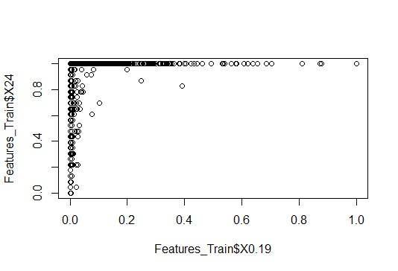
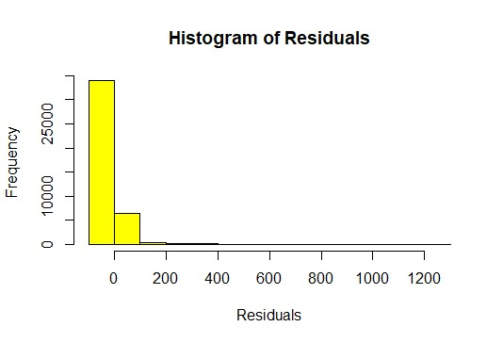

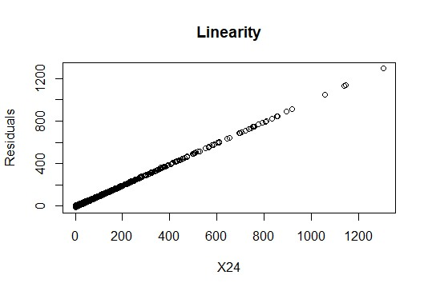

> fit<-lm(X0.19~X24+X463+X11.291044776119403+X1.0+X70.49513846124168, data=Fe atures_Variant_1)
> fit<-lm(X0.19~X24+X463+X11.291044776119403+X1.0+X70.49513846124168, data=Fe atures_Variant_1)
> fit

Call:
lm(formula = X0.19 ~ X24 + X463 + X11.291044776119403 + X1.0 + X70.49513846124168, data = Features_Variant_1)

Coefficients:
(Intercept) X24 X463 X11.2910447761
19403

0e-02

-1.765e+01 7.229e-01 3.037e-06 6.93

X1.0 X70.49513846124168
5.878e-02 2.513e-02

> summary(fit)

Call:
lm(formula = X0.19 ~ X24 + X463 + X11.291044776119403 + X1.0 + X70.49513846124168, data = Features_Variant_1)

Residuals:
Min  -235.02 | 1Q  -5.38 | Median  -1.03 | 3Q  0.17 | Max  1266.57

Coefficients:

Estimate Std. Error t value Pr(>|t|)
(Intercept) -1.765e+01 2.079e+00 -8.490 < 2e-16 *** X24 7.229e-01 8.654e-02 8.354 < 2e-16 *** X463 3.037e-06 1.785e-06 1.701 0.088916 . X11.291044776119403 6.930e-02 1.775e-02 3.905 9.46e-05 *** X1.0 5.878e-02 1.530e-02 3.841 0.000123 *** X70.49513846124168 2.513e-02 7.821e-03 3.213 0.001315 **
---
Signif. codes: 0 ‘***’ 0.001 ‘**’ 0.01 ‘*’ 0.05 ‘.’ 0.1 ‘ ’ 1

Residual standard error: 33.41 on 40942 degrees of freedom
Multiple R-squared: 0.1141, Adjusted R-squared: 0.114
F-statistic: 1054 on 5 and 40942 DF, p-value: < 2.2e-16

> vif(fit)

.0

25

X24 X463 X11.291044776119403 X1

1.012425 1.438330 87.332985 42.0345
X70.49513846124168
14.928307

plot(cv$lambda.min) plot(model) plot(model$bestTun) plot(model)
plot(varImp(ridge$finalModel))

plot(cv)

plot(ridge)

hist(Features$X0.19,col = "green") hist(Features$X24,col = "red") hist(Features$X11.291044776119403,col = 'yellow') fit = glmnet(x, y)
plot(fit)

cvfit = cv.glmnet(x, y)

plot(cvfit)

tfit=glmnet(x,y,lower=-.7,upper=.5)

plot(tfit)

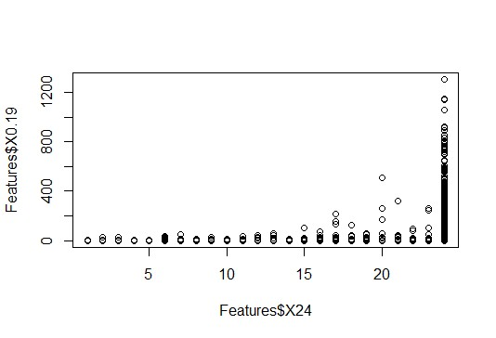

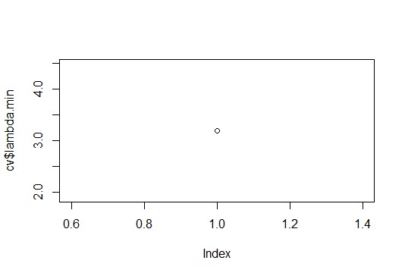
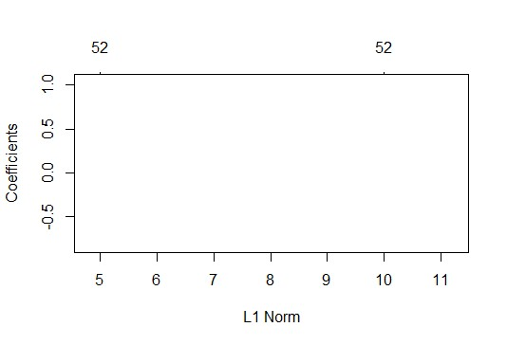

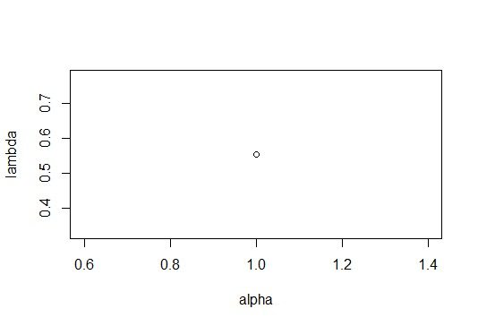

plot( lasso)
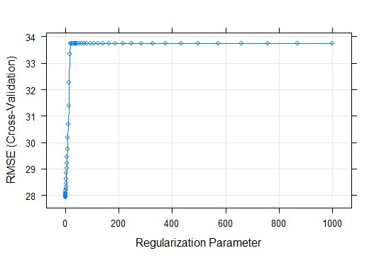

plot( predictions)

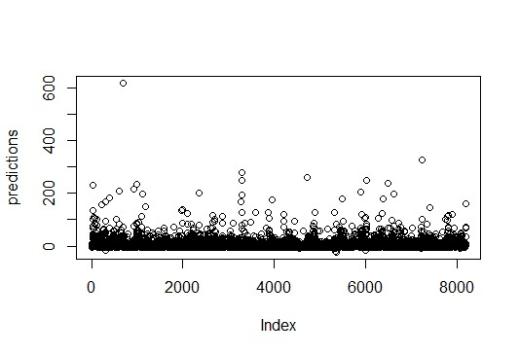

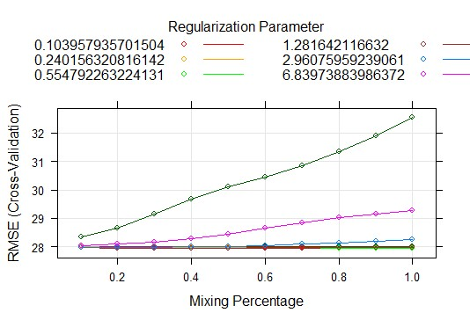

plot(varImp(ridge$finalModel))

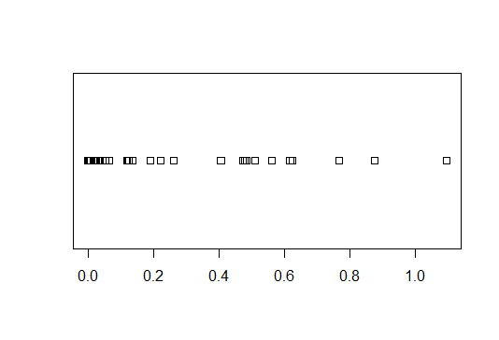

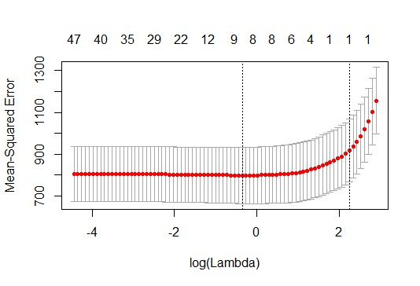

plot(ridge)

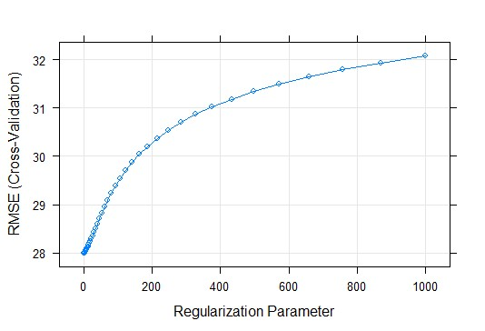
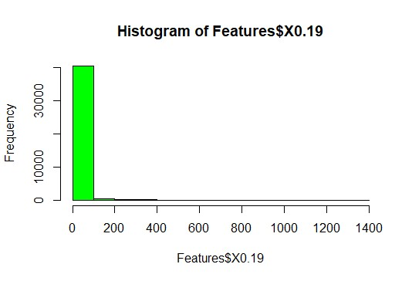

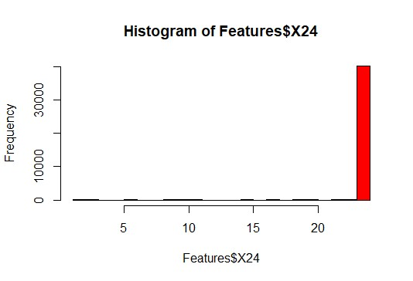
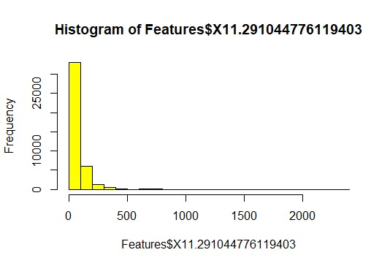

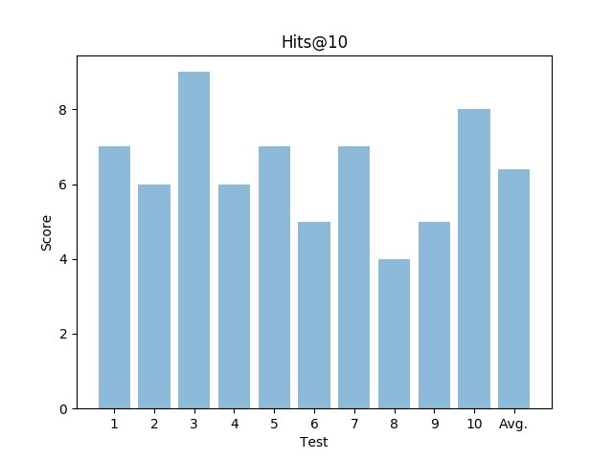
fit = glmnet(x, y)

plot(fit)

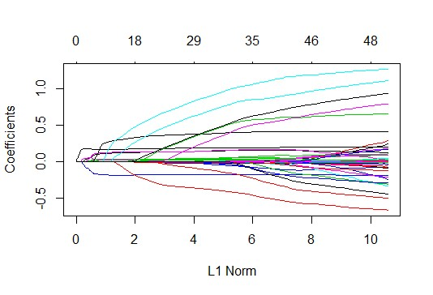

tfit=glmnet(x,y,lower=-.7,upper=.5)

plot(tfit)

